Logbook Help - Converting the Help.html to PDF.

What I did:
- Open the Help in Logbook
- Save the Help.html on disk as Help.html
- Open that Help.html in WORD
- Set Page-layout to Landscape
- Set Margins to "small"
- Adjust text and images so that -in "View"-"Weblayout"- it looks in WORD the same as in the html-file.
- Save as WORD-document
- Export from WORD to PDF.

Note:

In WORD it is possible to edit all hyperlinks at once by presing Alt-F9 and then "Search and Replace".
But I found out that in the PDF-file the hyperlinks are different from the html-file (and WORD-file).

Example:
Original hyperlink:
file:///C:/Program%20Files%20(x86)/OpenCPN/plugins/logbookkonni_pi/data/Help.html" \l layoutAlter

In the PDF this got changed to:
file:///C:/Program%20Files%20(x86)/OpenCPN/plugins/logbookkonni_pi/data/Help.html%23layoutAlter"

Don't know how to fix that yet...

Roel Smidt, 2017/02/10

Update:
In the WORD-document all hyperlinks seem to lead to this location:
file:///C:\Program Files(x86)\OpenCPN\plugins\logbookkonni_pi\data\Help.html#.........

(where the text after "#" points to a specific place in the document).

Example: the link that is attached to "Miscellaneous"
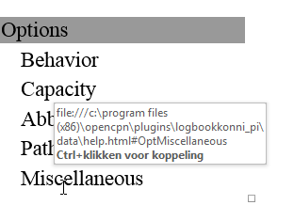
Suggestion to test:

If we want all the internal links to point to a location in the file itself, we will have to remove the highlighted text in all (internal) hyperlinks.
"file:///C:/Program%20Files%20(x86)/OpenCPN/plugins/logbookkonni_pi/data/Help.html"

Lets try:

Well, that seems to work OK.
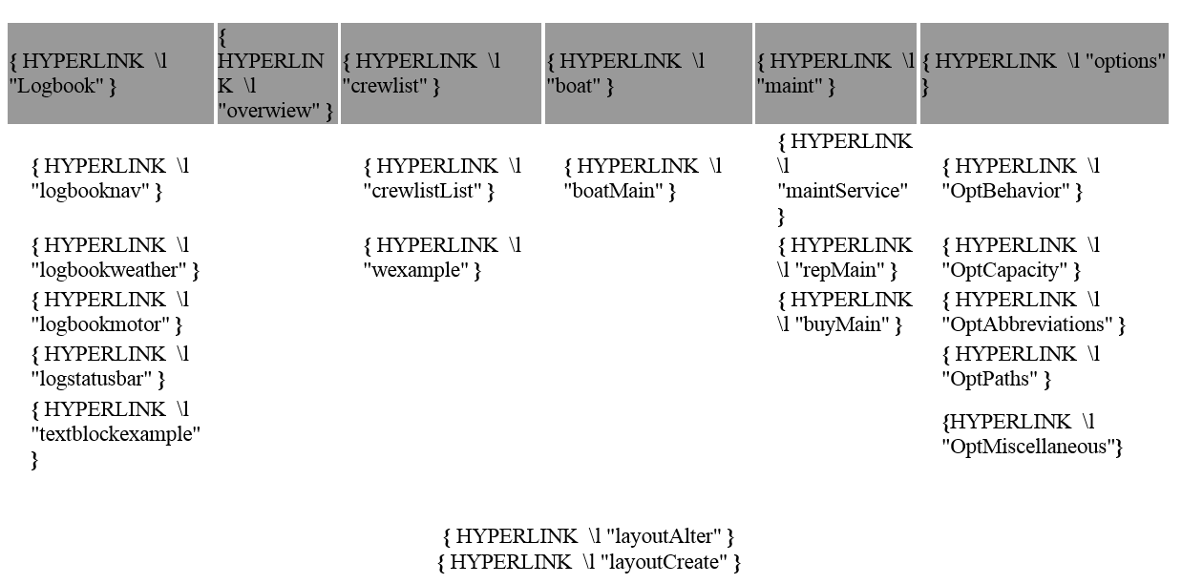

The only problem are the hyperlinks that are "hidden" in the screenshots.
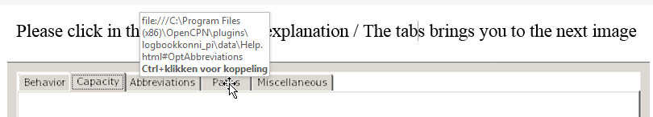

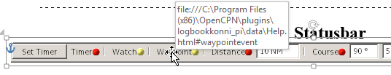
These links still point to the html-file. Hmmmm.

Info from Internet (Allan Wyatts Word Tips) http://wordribbon.tips.net/T010524_Easily_Changing_Links_in_Documents.html

When you insert pictures as links in your document, they are inserted as INCLUDEPICTURE fields. You can see this if you select the picture and press Shift+F9. You should then, instead of the picture, see a field similar to the following:
{ INCLUDEPICTURE "R:\\CommonPics\\masthead.jpg" \* MERGEFORMAT \d }

With the field code displayed, the contents of that field code can easily be changed using the Find and Replace capabilities of Word. Thus, you can change the drive and path by following these general steps:
- Load the document containing the links.
- Press Alt+F9 to display all the field codes in the document.
- Press Ctrl+H to display the Replace tab of the Find and Replace dialog box. (See Figure 1.)
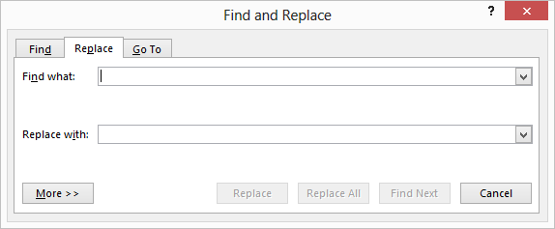
Figure 1. The Replace tab of the Find and Replace dialog box.
- In the Find What box, enter the drive and path name you want to change (such as R:\\CommonPics\\).
- In the Replace With box, enter the new drive and path name (such as K:\\NewPics\\).
- Click Replace All.
- Press Alt+F9 to display the field results for all fields in the document.
The links in the document are now all updated, and you can save your document.
If you have quite a few documents that you need to change, you may be interested in implementing the above steps in a macro. Creating the macro is easy (just record the above steps), but getting Word to perform the operation on a series of files, without intervention on your part, is a bit more involved. A good place to start to learn how to do this is at the Word MVP site:
http://wordmvp.com/FAQs/MacrosVBA/BatchFR.htm
Once you learn the technique of how to work with multiple files, you can then modify your single-file macro (the one you recorded) so it will work on more than one file.
WordTips is your source for cost-effective Microsoft Word training. (Microsoft Word is the most popular word processing software in the world.) This tip (10524) applies to Microsoft Word 2007, 2010, and 2013.

